Lab 7

# imgs/mountain.png

## imgs/mountain.png, section [200, 328, 200, 328], ratio 4:4:4

Y compression: 304.541015625 % , Cr compression 127.44140625% , Cb compression 164.84375%

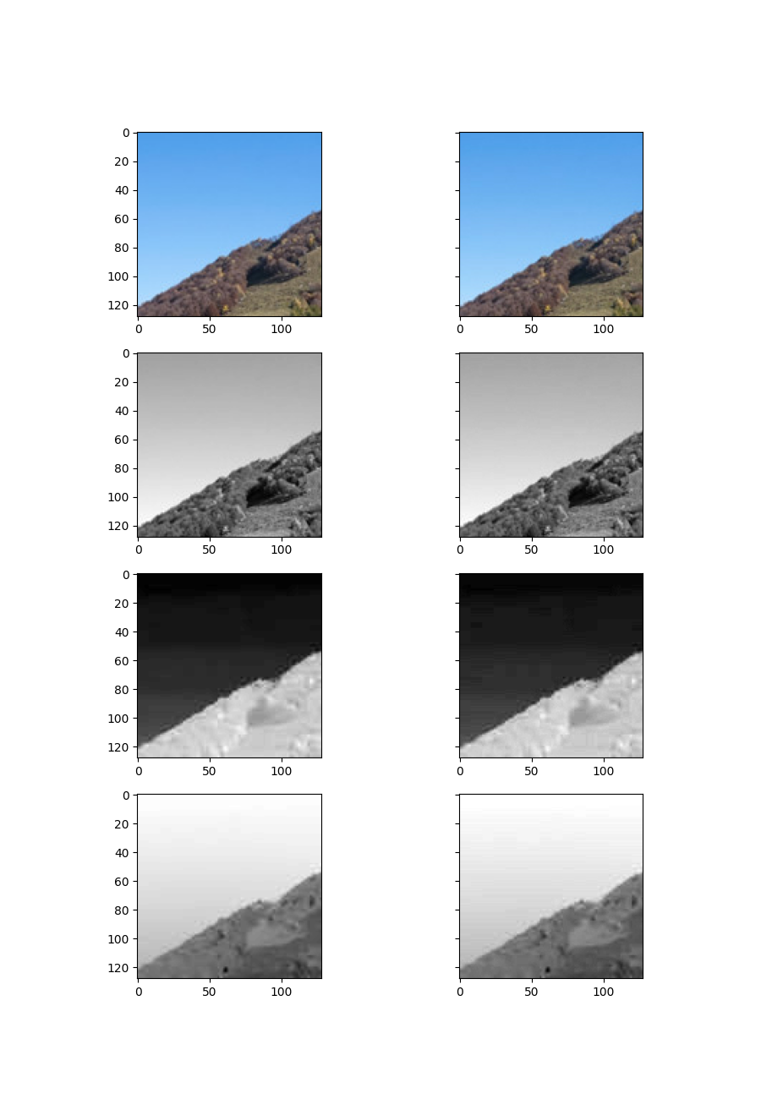

## imgs/mountain.png, section [200, 328, 200, 328], ratio 4:2:2

Y compression: 304.541015625 % , Cr compression 114.16015625% , Cb compression 129.345703125%

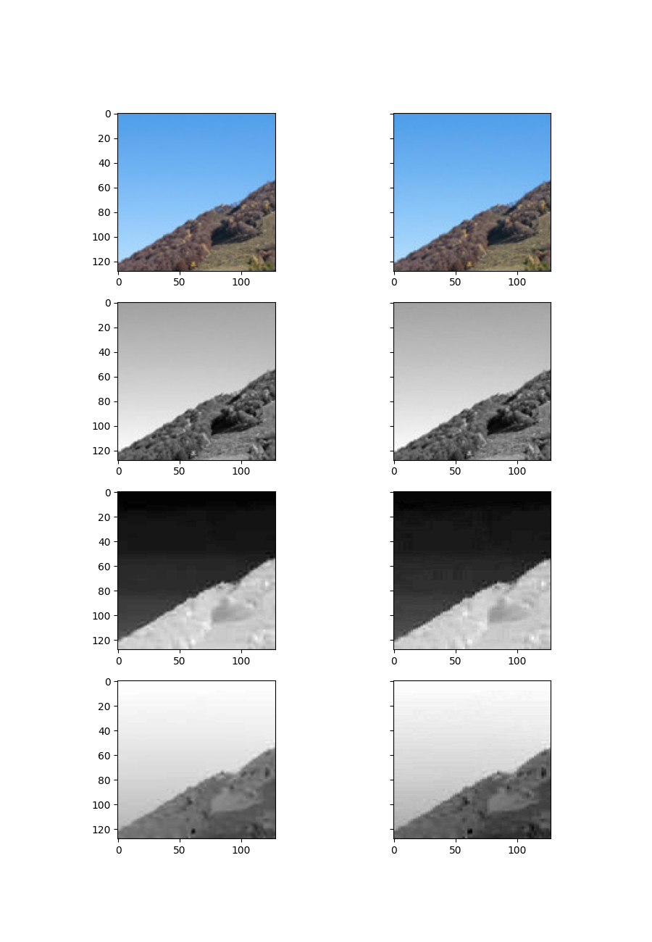

## imgs/mountain.png, section [200, 328, 200, 328], ratio 4:2:0

Y compression: 304.541015625 % , Cr compression 88.0859375% , Cb compression 92.08984375%

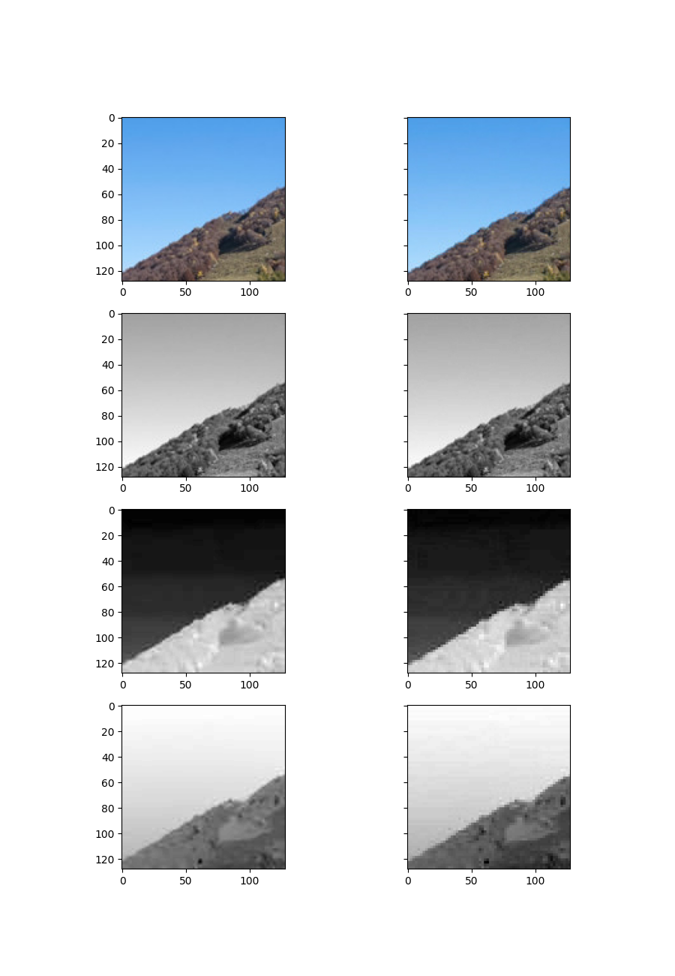

## imgs/mountain.png, section [400, 528, 400, 528], ratio 4:4:4

Y compression: 648.681640625 % , Cr compression 255.37109375% , Cb compression 335.693359375%

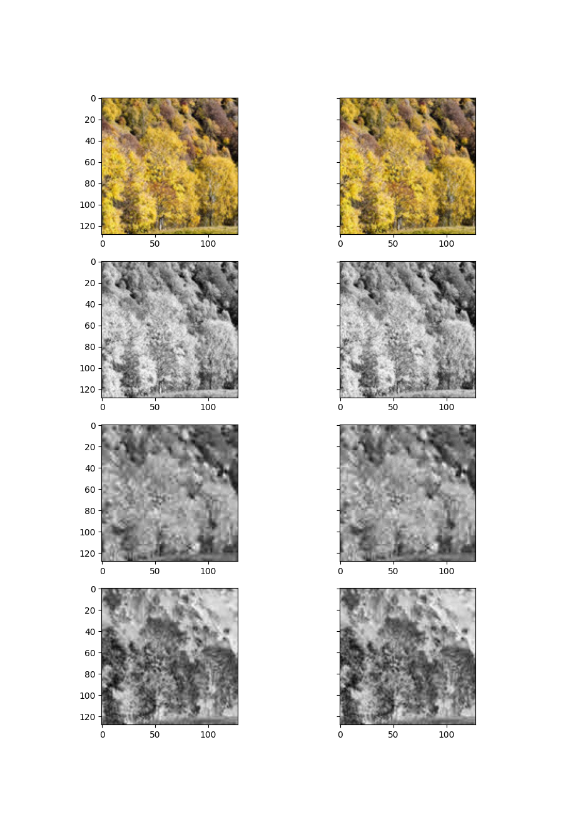

## imgs/mountain.png, section [400, 528, 400, 528], ratio 4:2:2

Y compression: 648.681640625 % , Cr compression 225.48828125% , Cb compression 296.875%

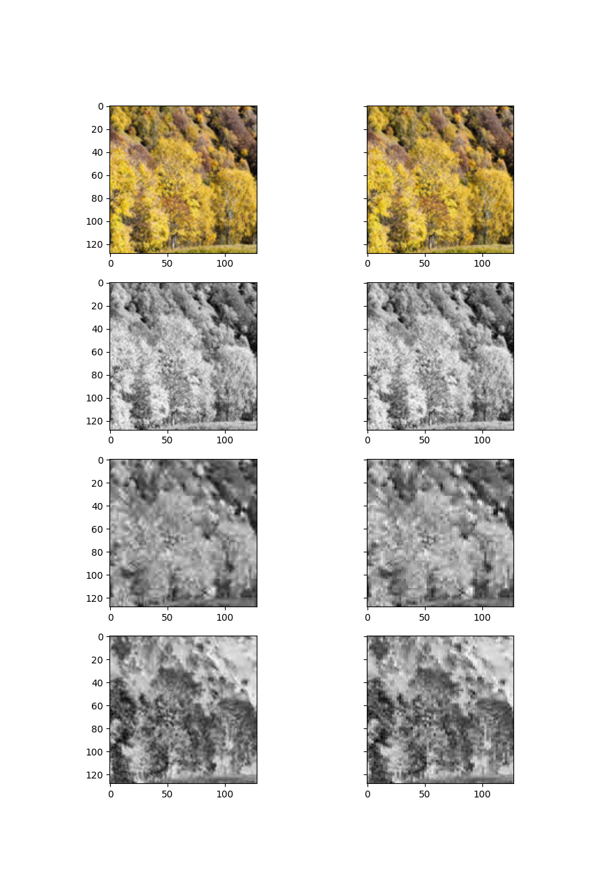

## imgs/mountain.png, section [400, 528, 400, 528], ratio 4:2:0

Y compression: 648.681640625 % , Cr compression 180.810546875% , Cb compression 193.5546875%

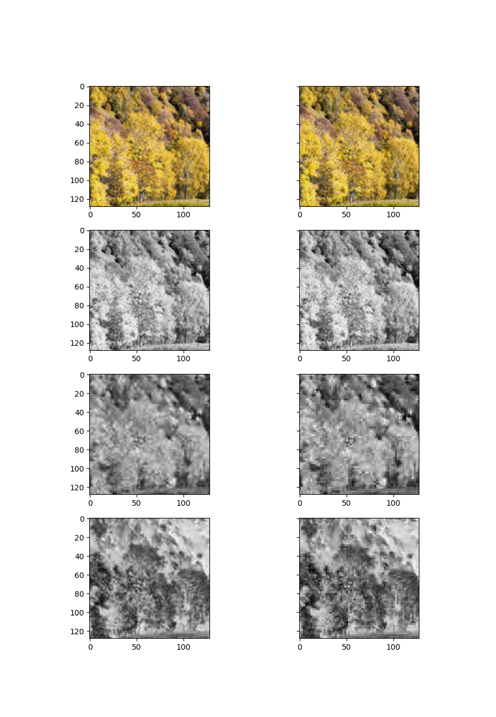

## imgs/mountain.png, section [130, 258, 130, 258], ratio 4:4:4

Y compression: 249.365234375 % , Cr compression 133.251953125% , Cb compression 118.408203125%

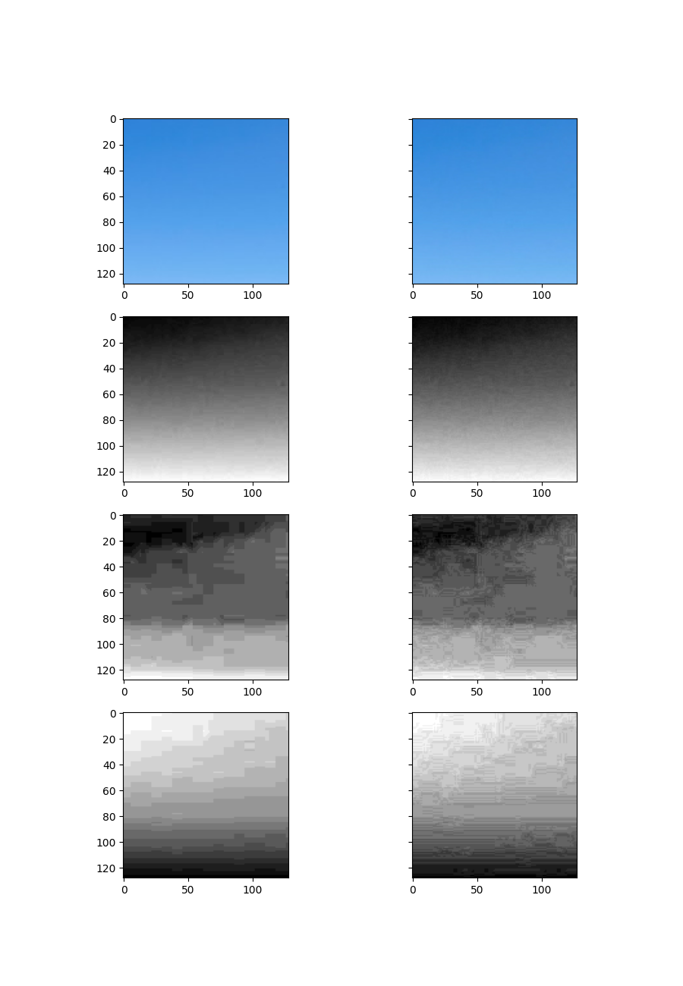

## imgs/mountain.png, section [130, 258, 130, 258], ratio 4:2:2

Y compression: 249.365234375 % , Cr compression 79.541015625% , Cb compression 66.015625%

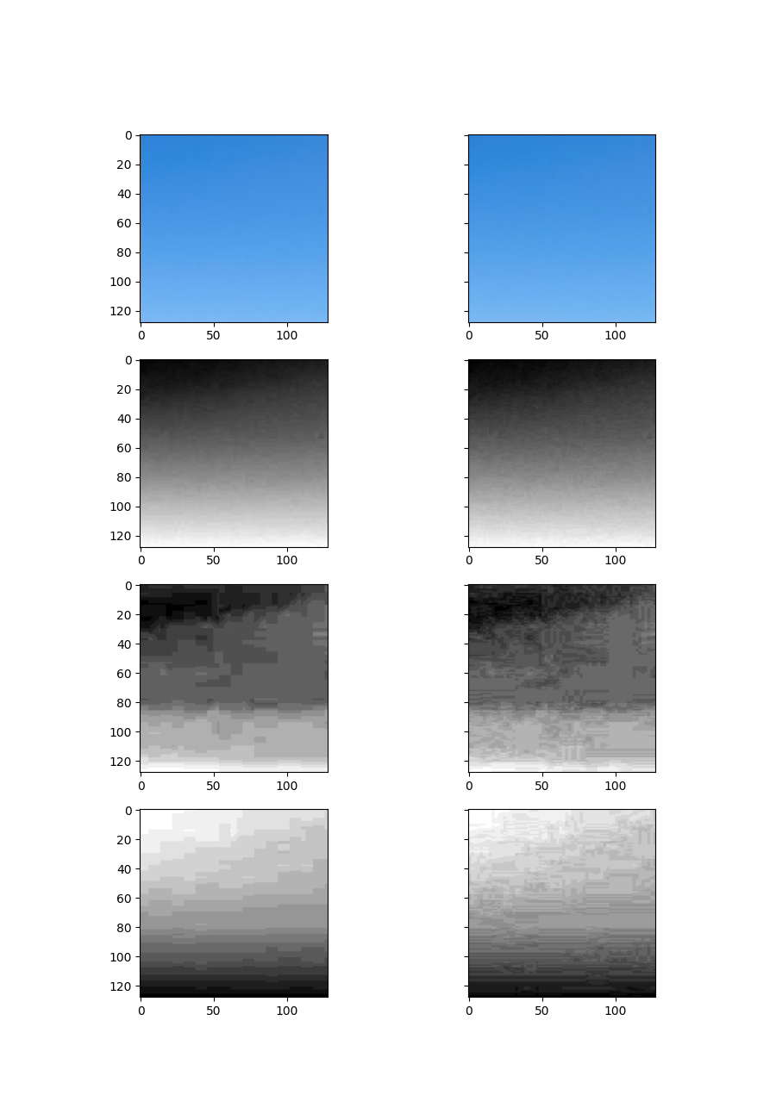

## imgs/mountain.png, section [130, 258, 130, 258], ratio 4:2:0

Y compression: 249.365234375 % , Cr compression 47.021484375% , Cb compression 37.451171875%

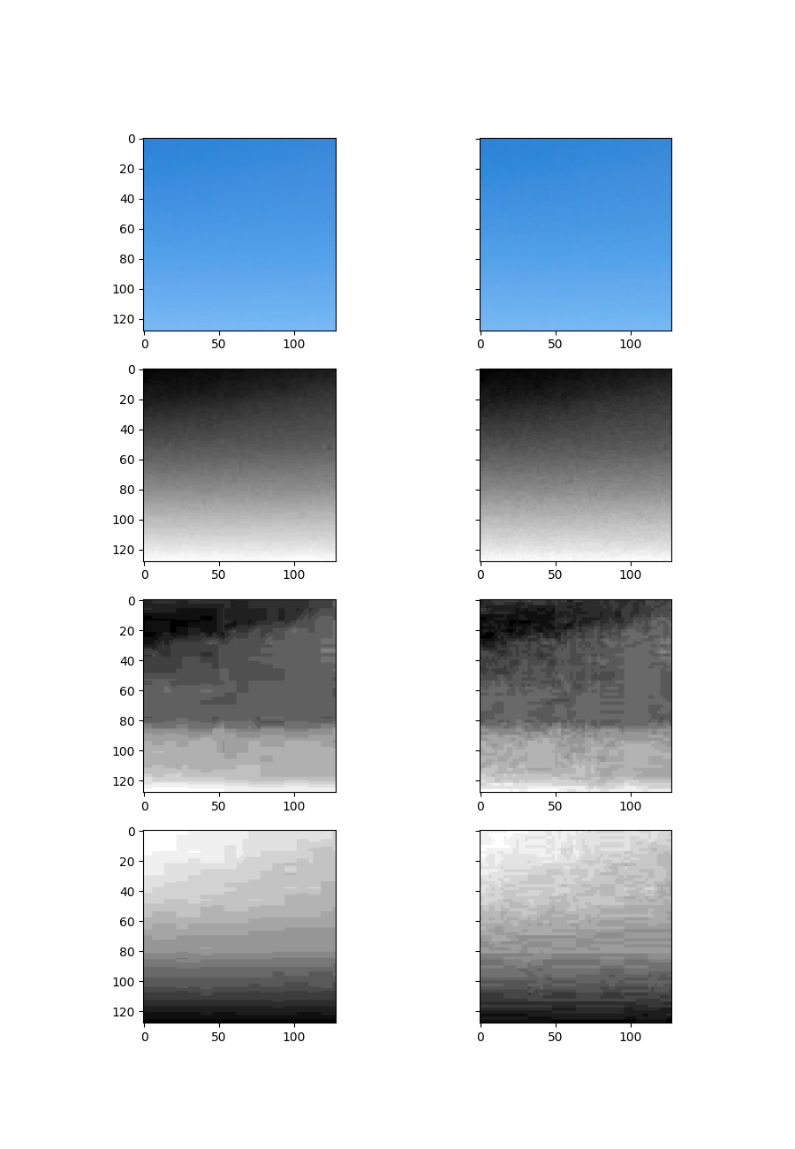

# imgs/cars.png

## imgs/cars.png, section [200, 328, 200, 328], ratio 4:4:4

Y compression: 568.1640625 % , Cr compression 119.482421875% , Cb compression 180.615234375%

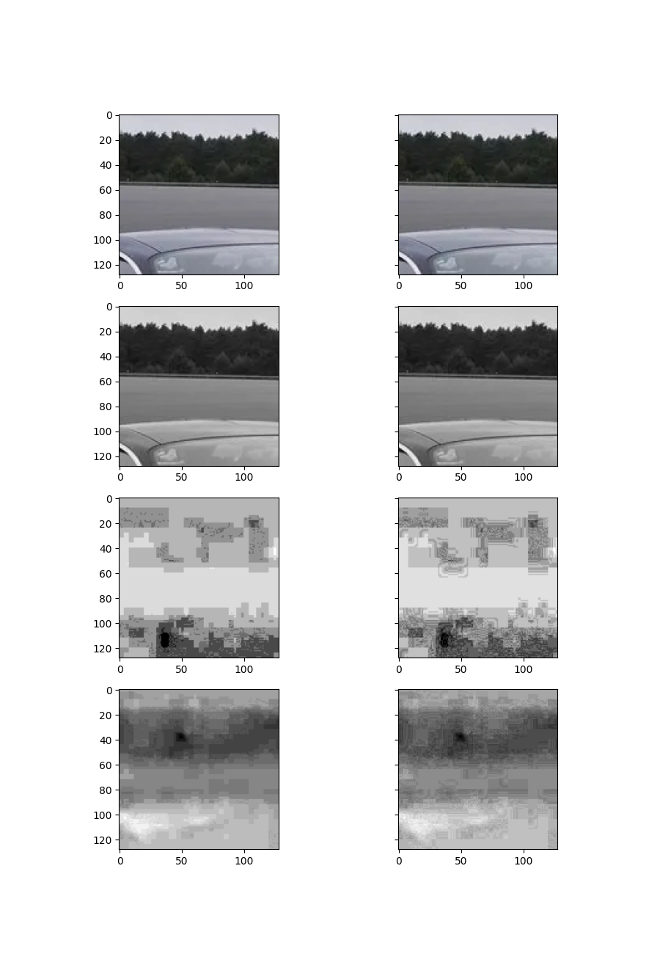

## imgs/cars.png, section [200, 328, 200, 328], ratio 4:2:2

Y compression: 568.1640625 % , Cr compression 78.90625% , Cb compression 119.189453125%

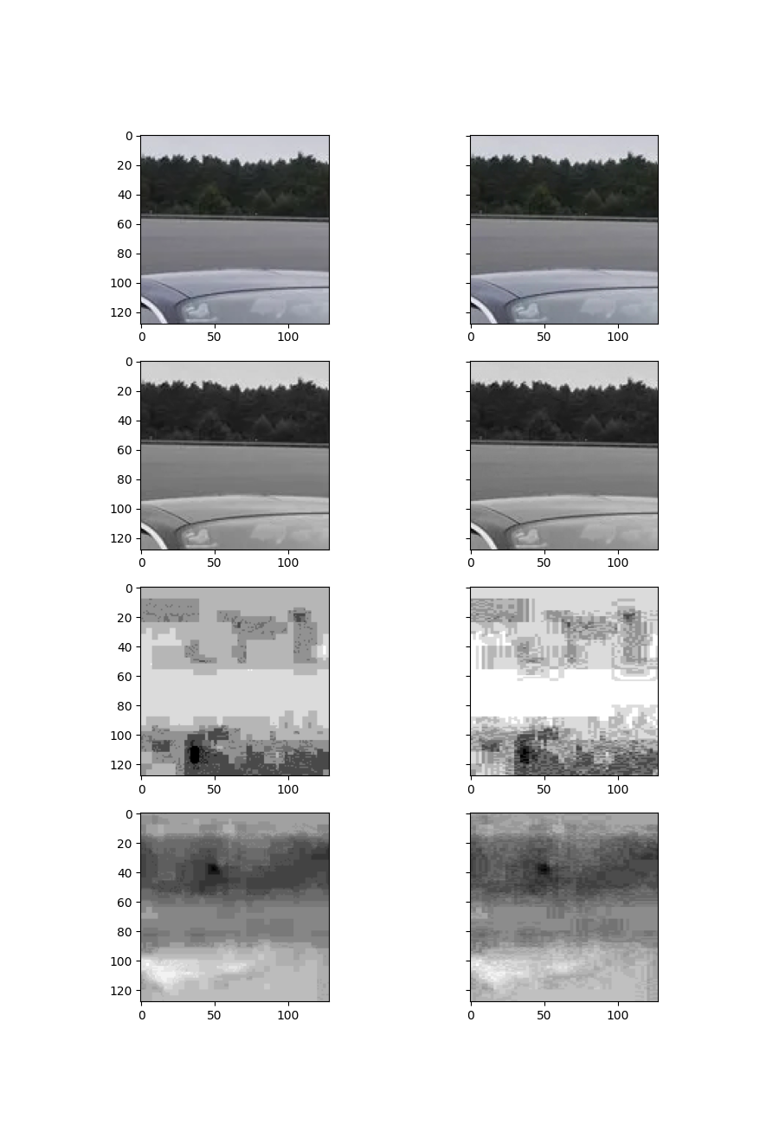

## imgs/cars.png, section [200, 328, 200, 328], ratio 4:2:0

Y compression: 568.1640625 % , Cr compression 55.46875% , Cb compression 77.099609375%

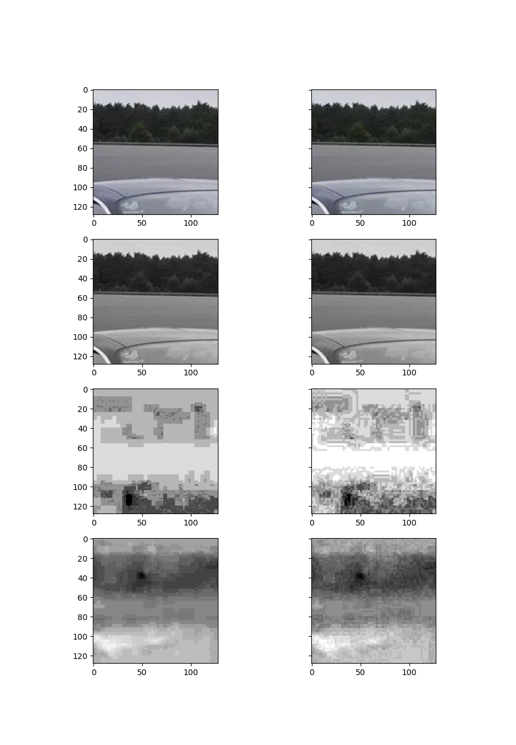

## imgs/cars.png, section [400, 528, 400, 528], ratio 4:4:4

Y compression: 629.150390625 % , Cr compression 329.150390625% , Cb compression 349.267578125%

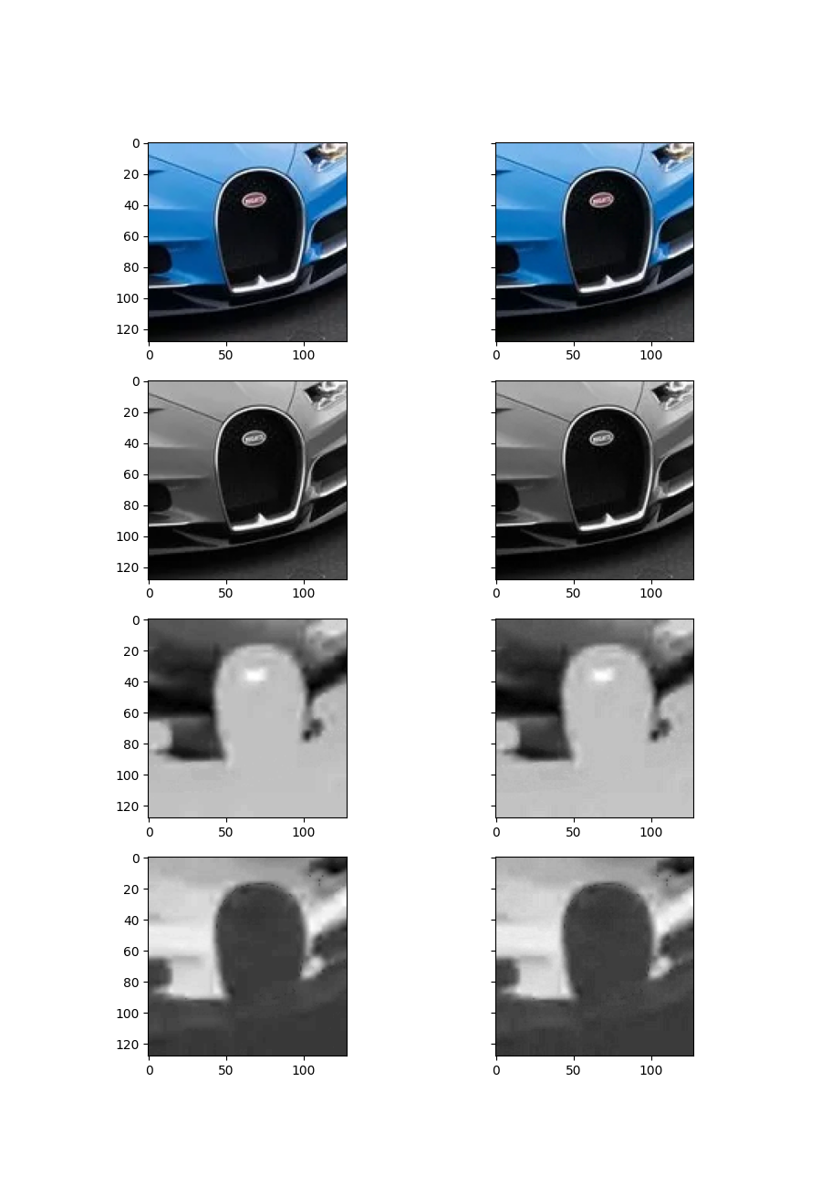

## imgs/cars.png, section [400, 528, 400, 528], ratio 4:2:2

Y compression: 629.150390625 % , Cr compression 189.404296875% , Cb compression 202.978515625%

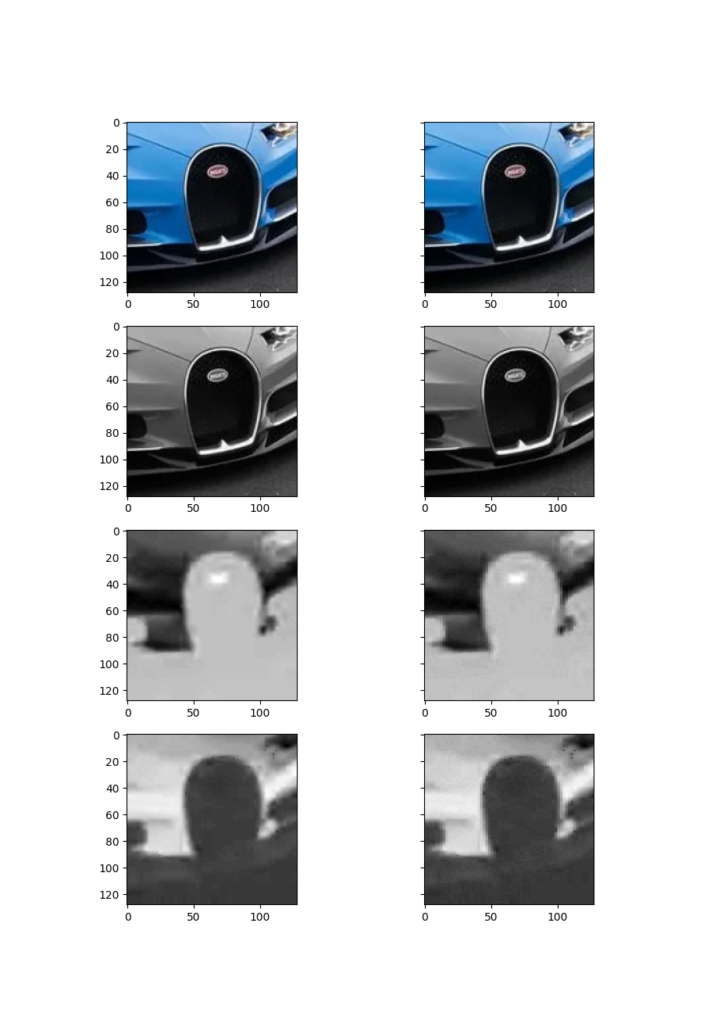

## imgs/cars.png, section [400, 528, 400, 528], ratio 4:2:0

Y compression: 629.150390625 % , Cr compression 106.93359375% , Cb compression 117.529296875%

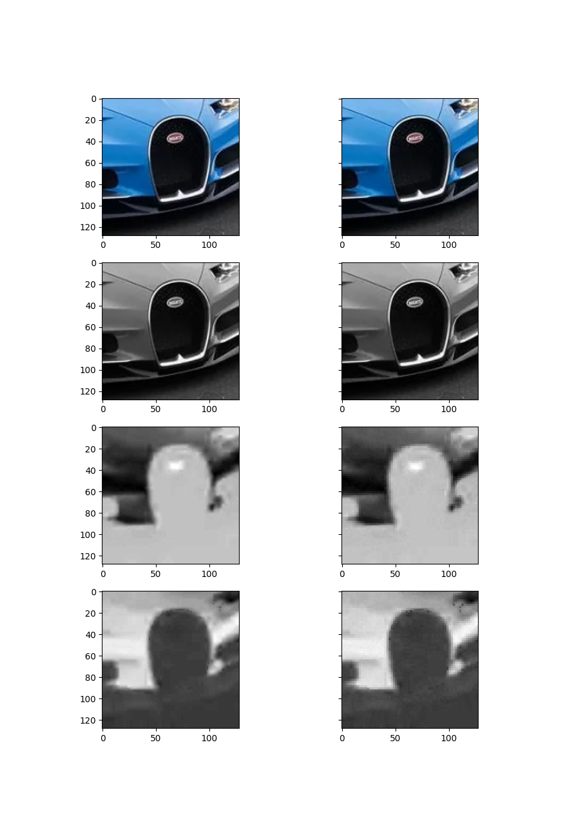

## imgs/cars.png, section [130, 258, 130, 258], ratio 4:4:4

Y compression: 426.708984375 % , Cr compression 135.9375% , Cb compression 170.654296875%

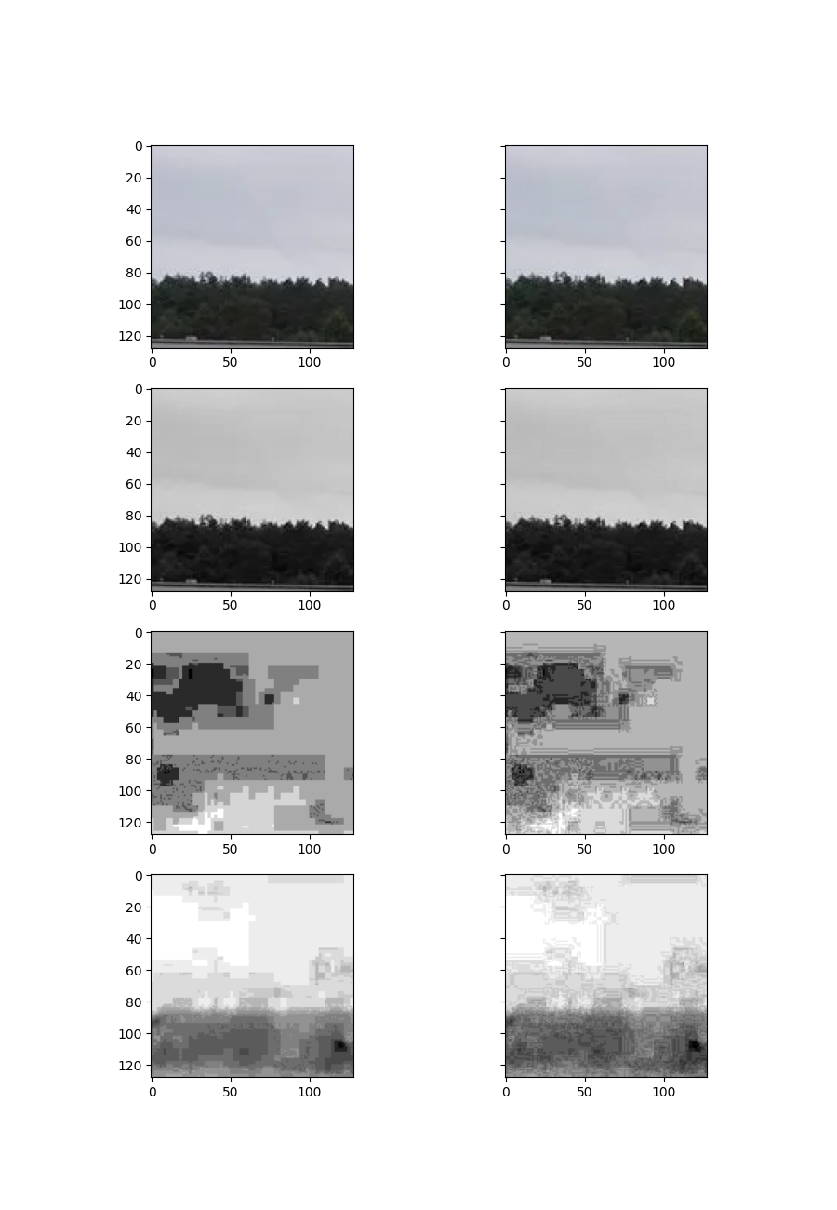

## imgs/cars.png, section [130, 258, 130, 258], ratio 4:2:2

Y compression: 426.708984375 % , Cr compression 80.76171875% , Cb compression 106.201171875%

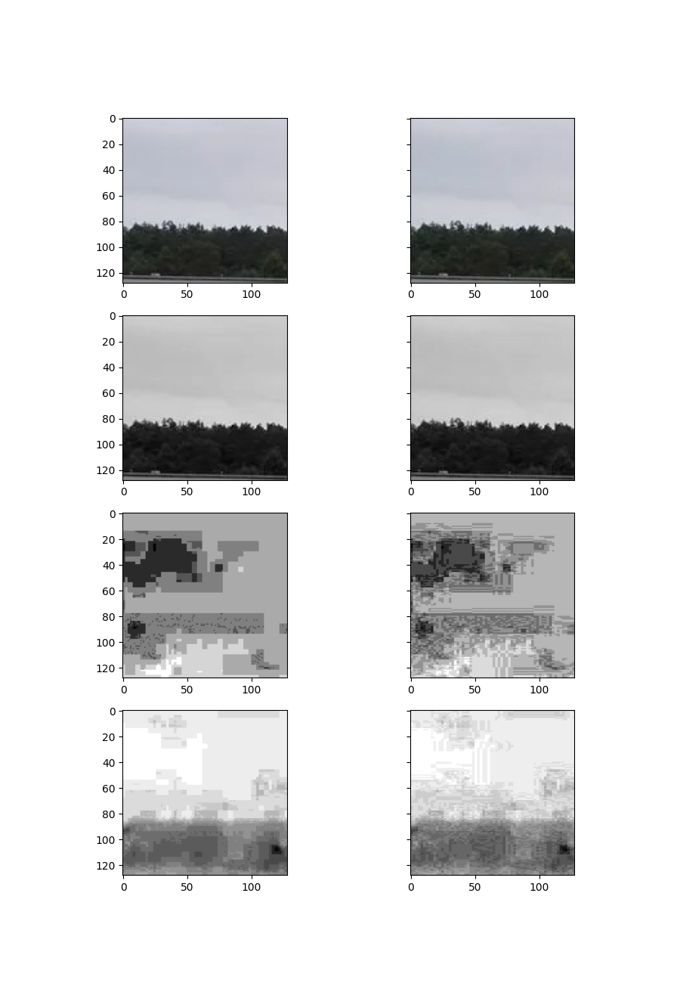

## imgs/cars.png, section [130, 258, 130, 258], ratio 4:2:0

Y compression: 426.708984375 % , Cr compression 51.07421875% , Cb compression 64.404296875%

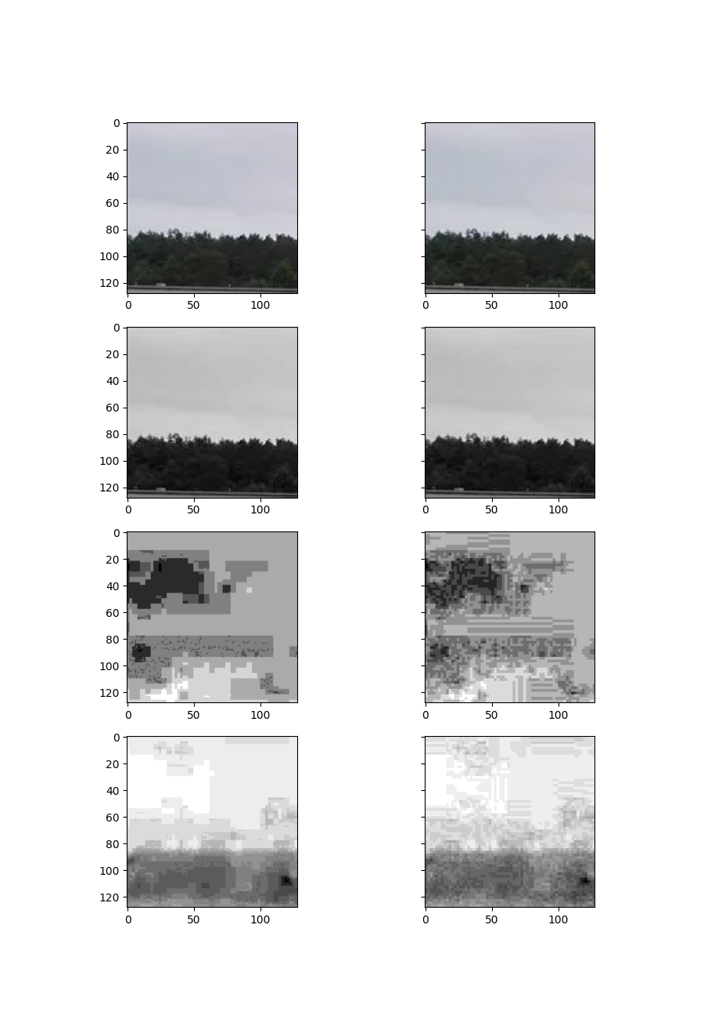

# imgs/food.png

## imgs/food.png, section [200, 328, 200, 328], ratio 4:4:4

Y compression: 695.458984375 % , Cr compression 433.49609375% , Cb compression 441.50390625%

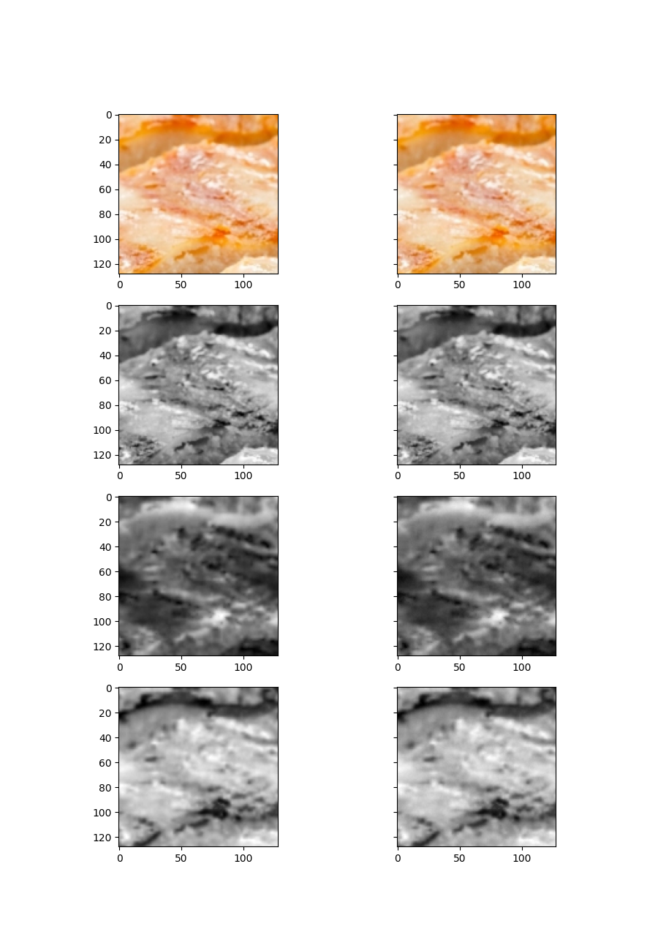

## imgs/food.png, section [200, 328, 200, 328], ratio 4:2:2

Y compression: 695.458984375 % , Cr compression 267.578125% , Cb compression 276.5625%

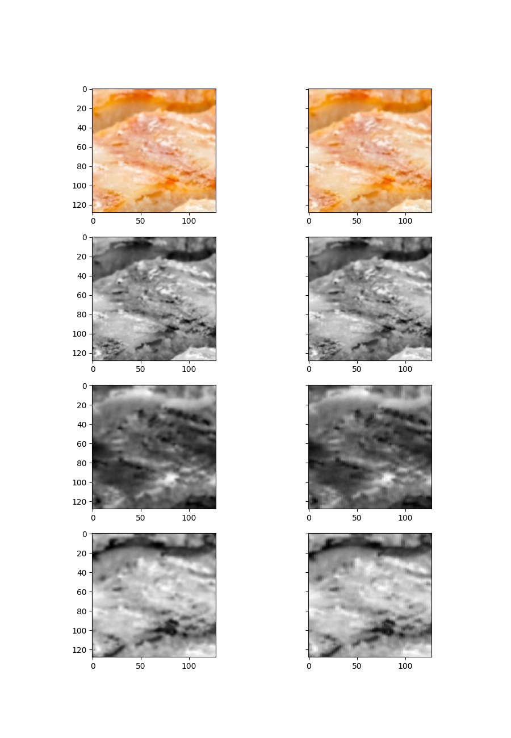

## imgs/food.png, section [200, 328, 200, 328], ratio 4:2:0

Y compression: 695.458984375 % , Cr compression 162.5% , Cb compression 166.69921875%

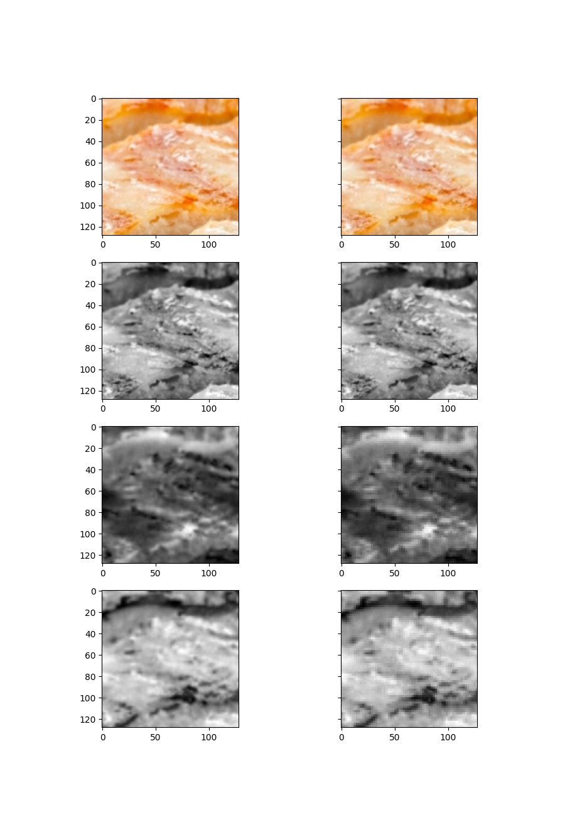

## imgs/food.png, section [400, 528, 400, 528], ratio 4:4:4

Y compression: 747.021484375 % , Cr compression 515.33203125% , Cb compression 523.095703125%

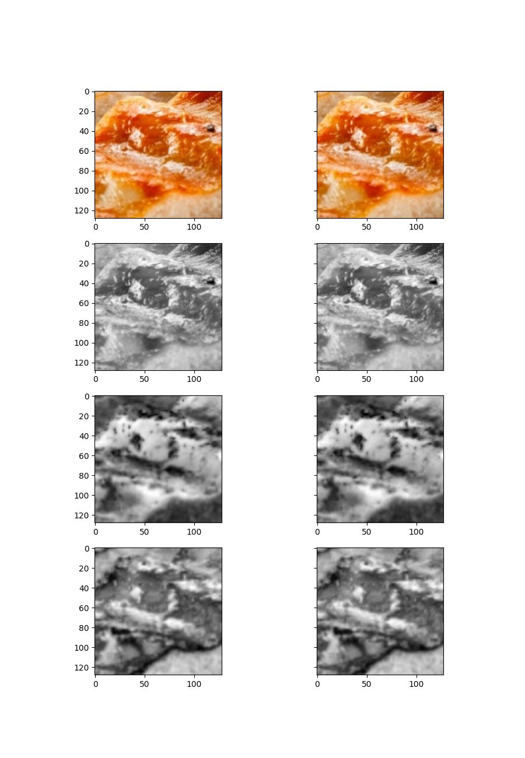

## imgs/food.png, section [400, 528, 400, 528], ratio 4:2:2

Y compression: 747.021484375 % , Cr compression 301.123046875% , Cb compression 305.6640625%

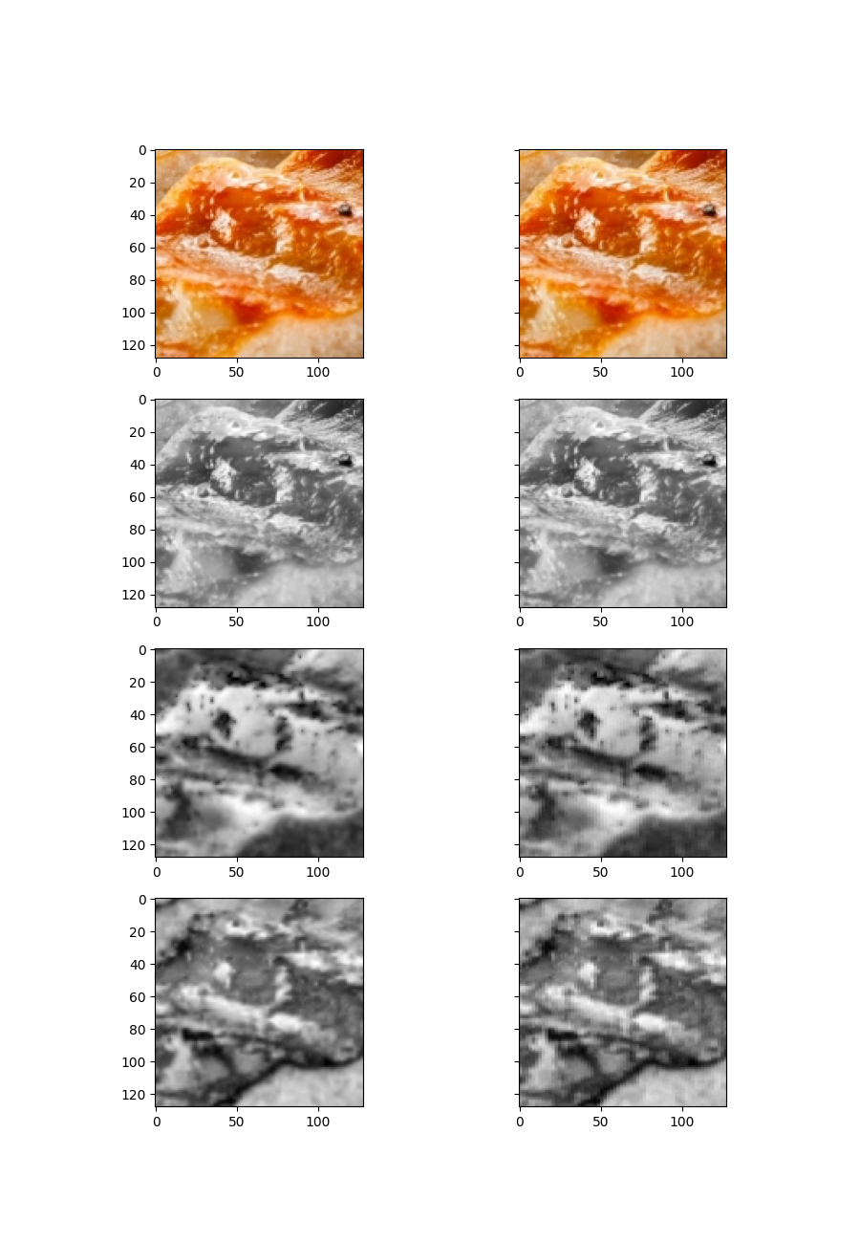

## imgs/food.png, section [400, 528, 400, 528], ratio 4:2:0

Y compression: 747.021484375 % , Cr compression 173.876953125% , Cb compression 178.857421875%

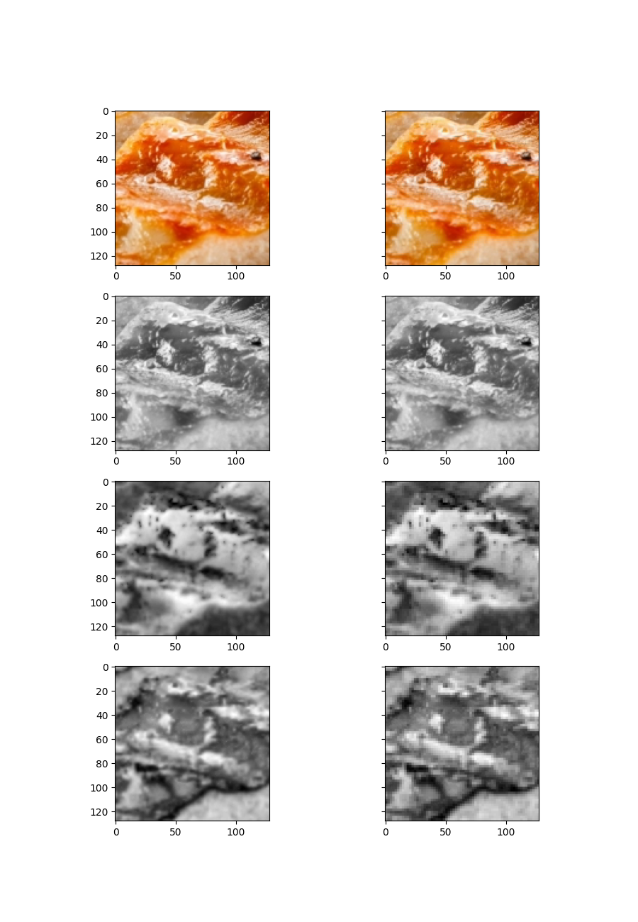

## imgs/food.png, section [130, 258, 130, 258], ratio 4:4:4

Y compression: 598.095703125 % , Cr compression 341.6015625% , Cb compression 356.591796875%

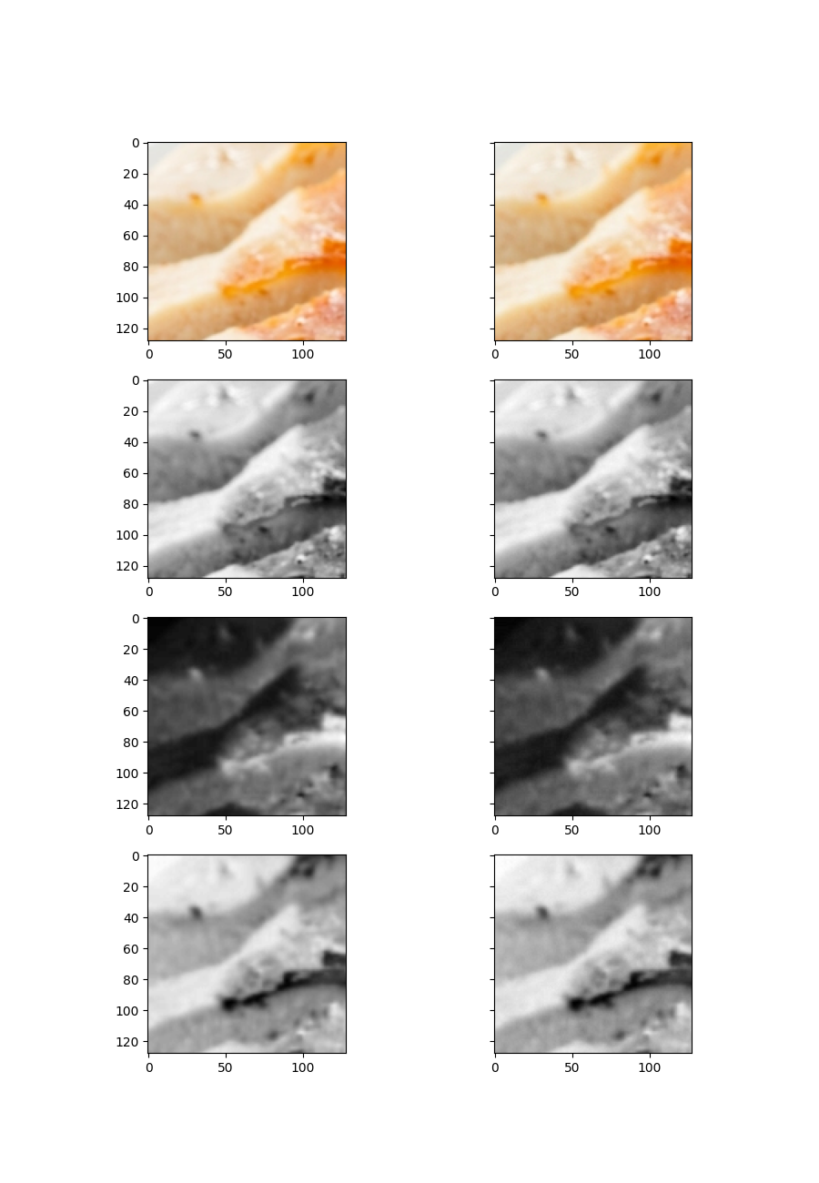

## imgs/food.png, section [130, 258, 130, 258], ratio 4:2:2

Y compression: 598.095703125 % , Cr compression 211.9140625% , Cb compression 220.1171875%

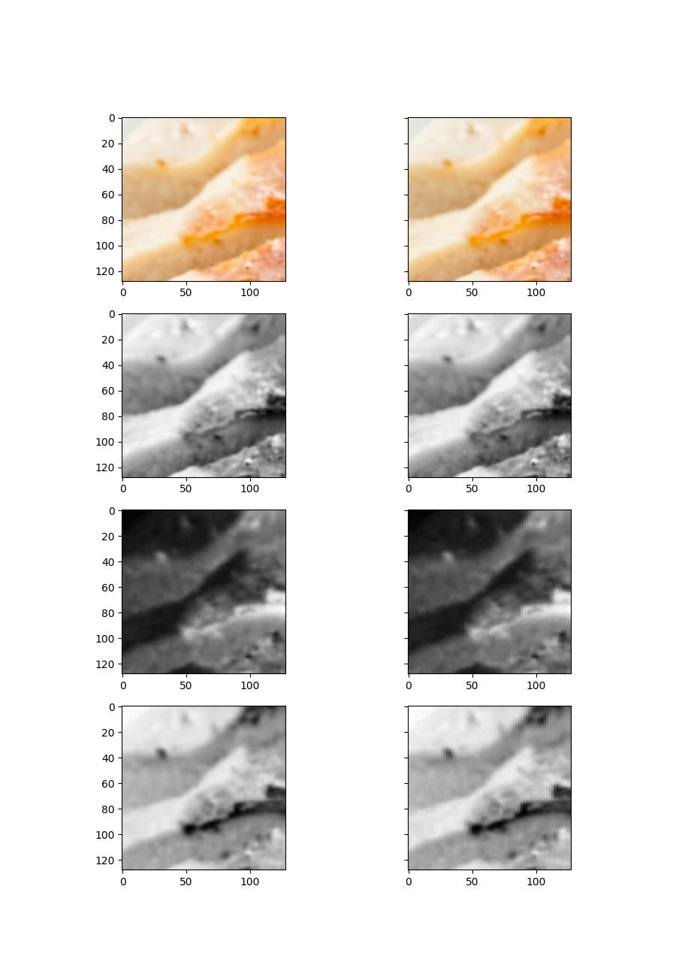

## imgs/food.png, section [130, 258, 130, 258], ratio 4:2:0

Y compression: 598.095703125 % , Cr compression 137.353515625% , Cb compression 142.08984375%

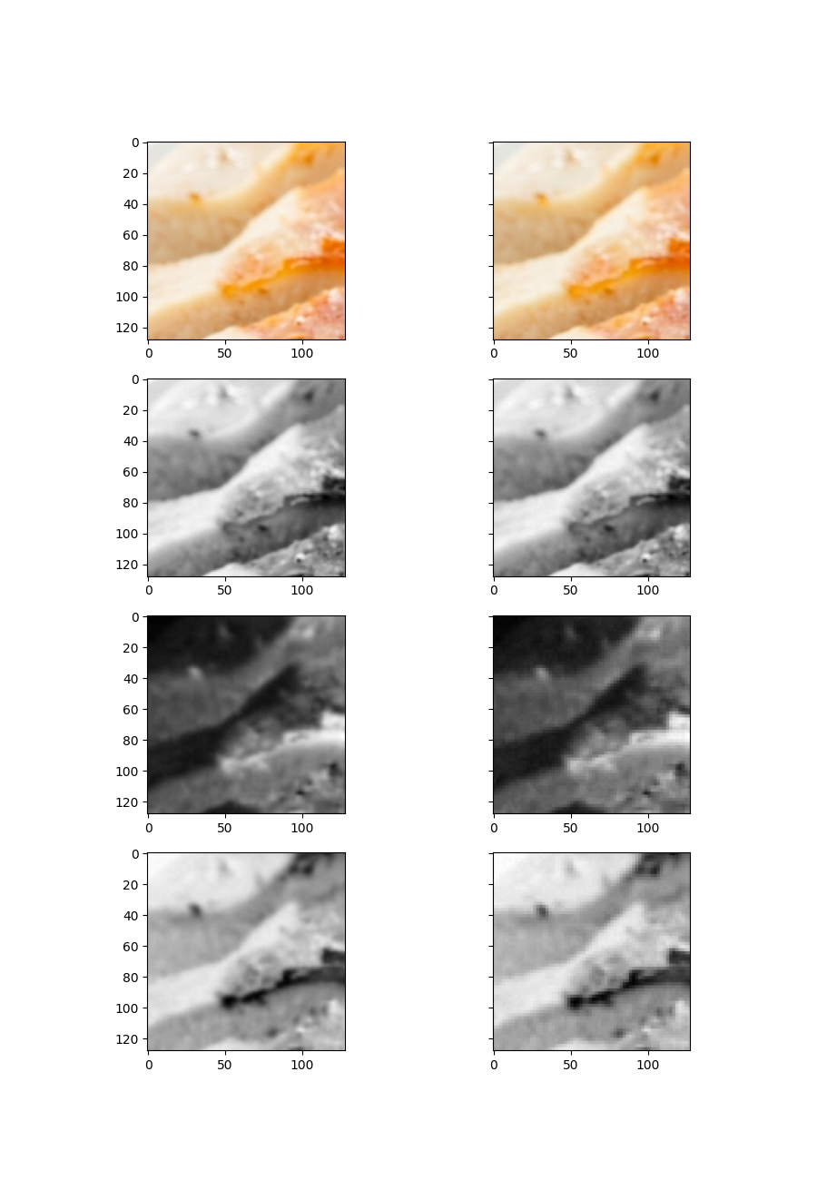

# imgs/capybara.png

## imgs/capybara.png, section [200, 328, 200, 328], ratio 4:4:4

Y compression: 331.787109375 % , Cr compression 212.451171875% , Cb compression 250.732421875%

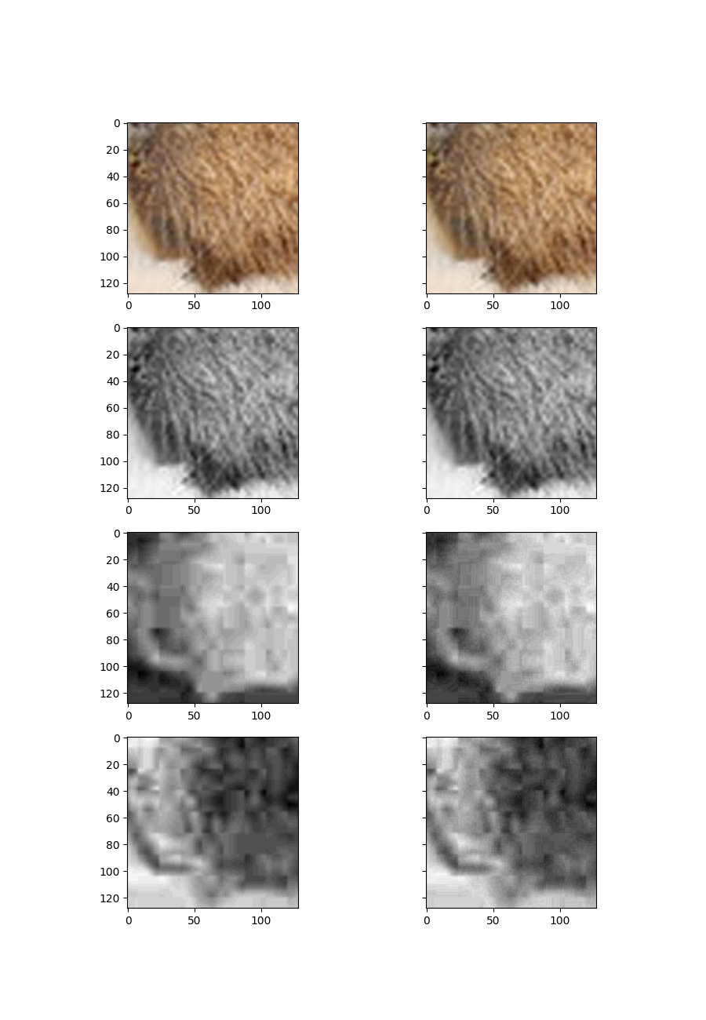

## imgs/capybara.png, section [200, 328, 200, 328], ratio 4:2:2

Y compression: 331.787109375 % , Cr compression 128.3203125% , Cb compression 152.783203125%

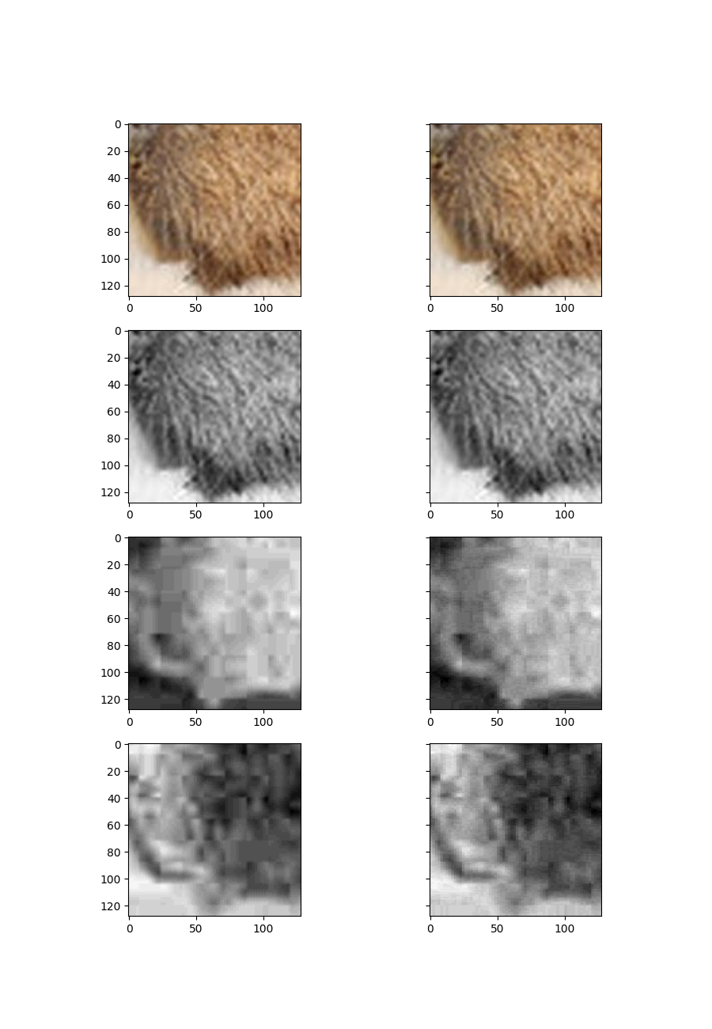

## imgs/capybara.png, section [200, 328, 200, 328], ratio 4:2:0

Y compression: 331.787109375 % , Cr compression 92.041015625% , Cb compression 107.8125%

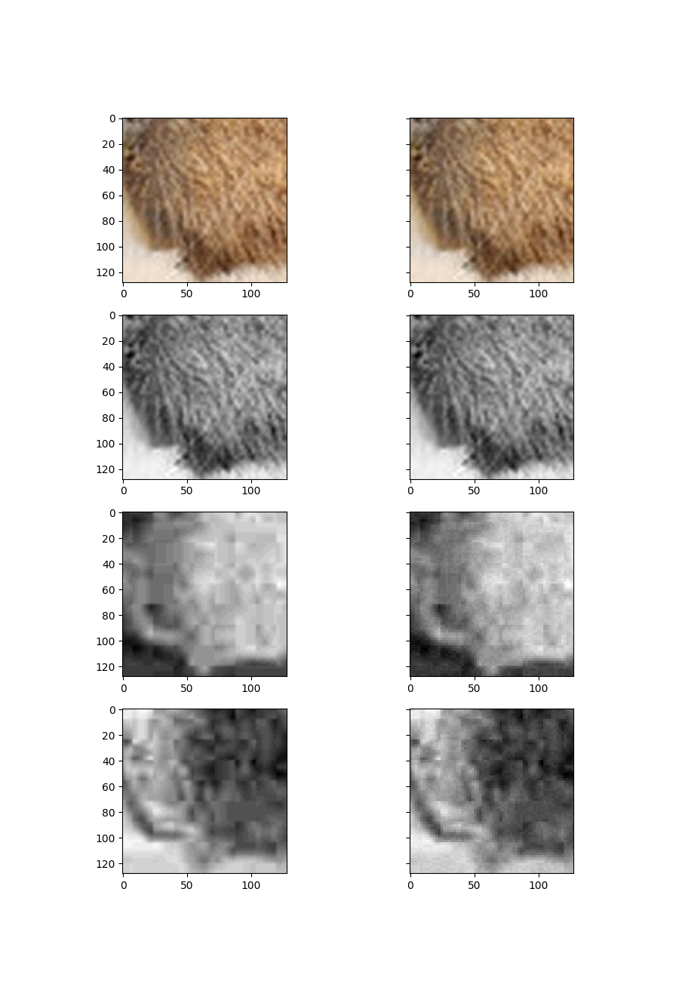

## imgs/capybara.png, section [400, 528, 400, 528], ratio 4:4:4

Y compression: 327.9296875 % , Cr compression 189.453125% , Cb compression 228.515625%

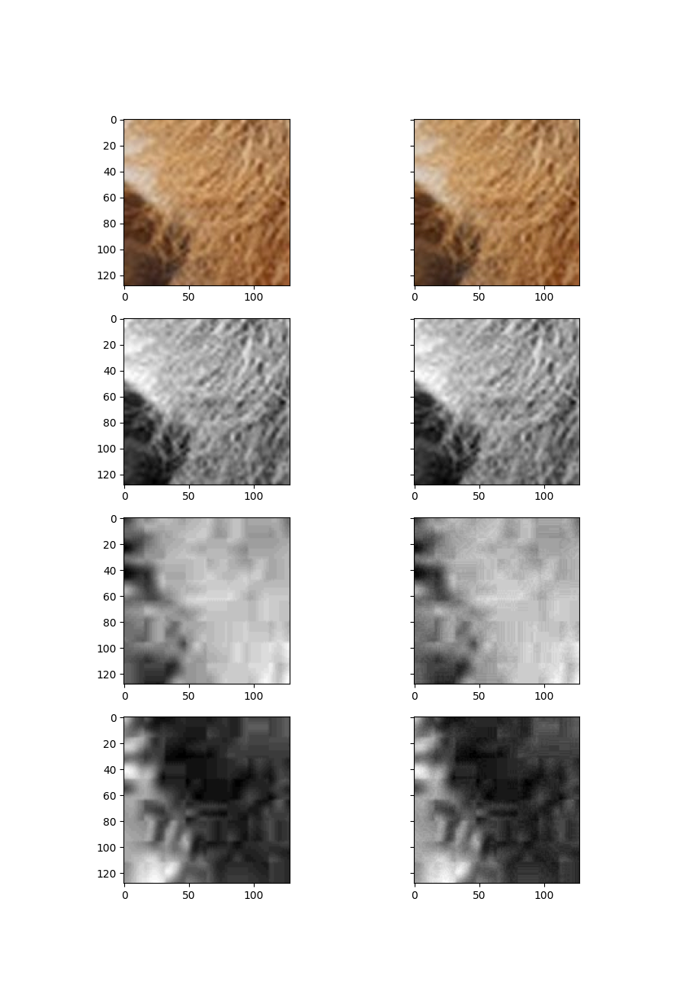

## imgs/capybara.png, section [400, 528, 400, 528], ratio 4:2:2

Y compression: 327.9296875 % , Cr compression 101.513671875% , Cb compression 121.728515625%

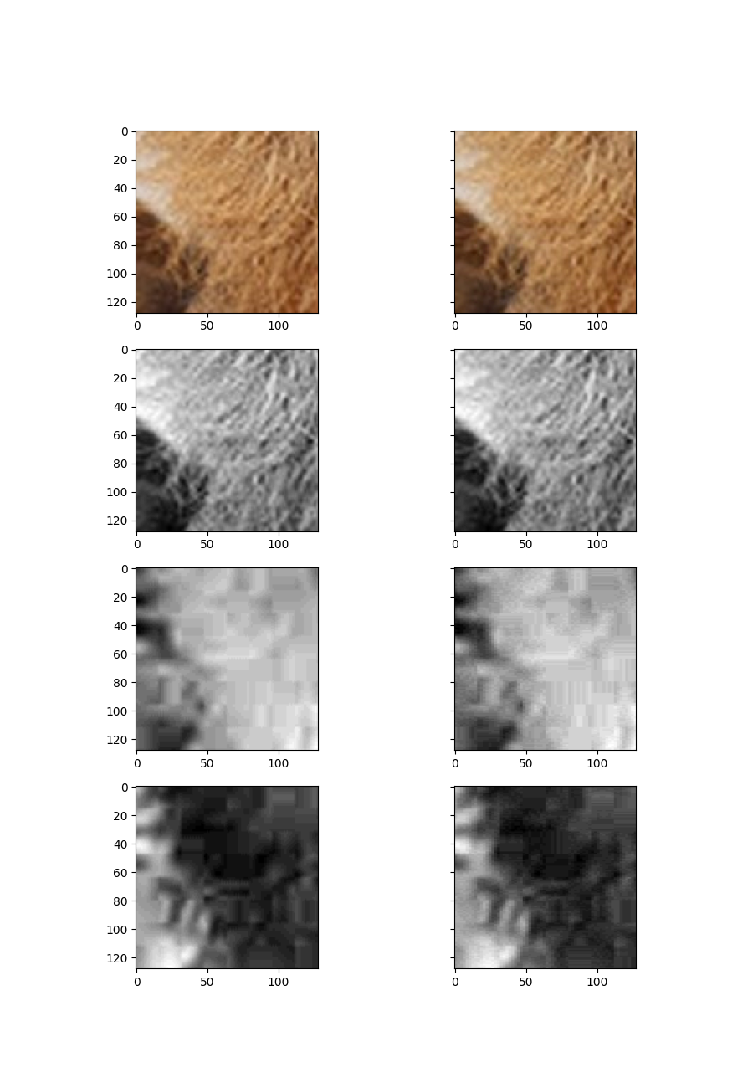

## imgs/capybara.png, section [400, 528, 400, 528], ratio 4:2:0

Y compression: 327.9296875 % , Cr compression 54.8828125% , Cb compression 65.966796875%

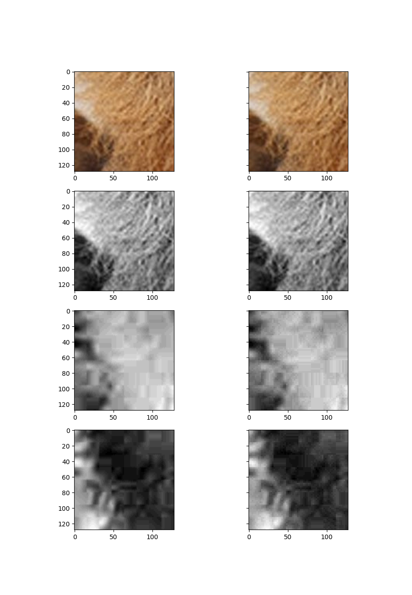

## imgs/capybara.png, section [130, 258, 130, 258], ratio 4:4:4

Y compression: 541.162109375 % , Cr compression 190.33203125% , Cb compression 222.94921875%

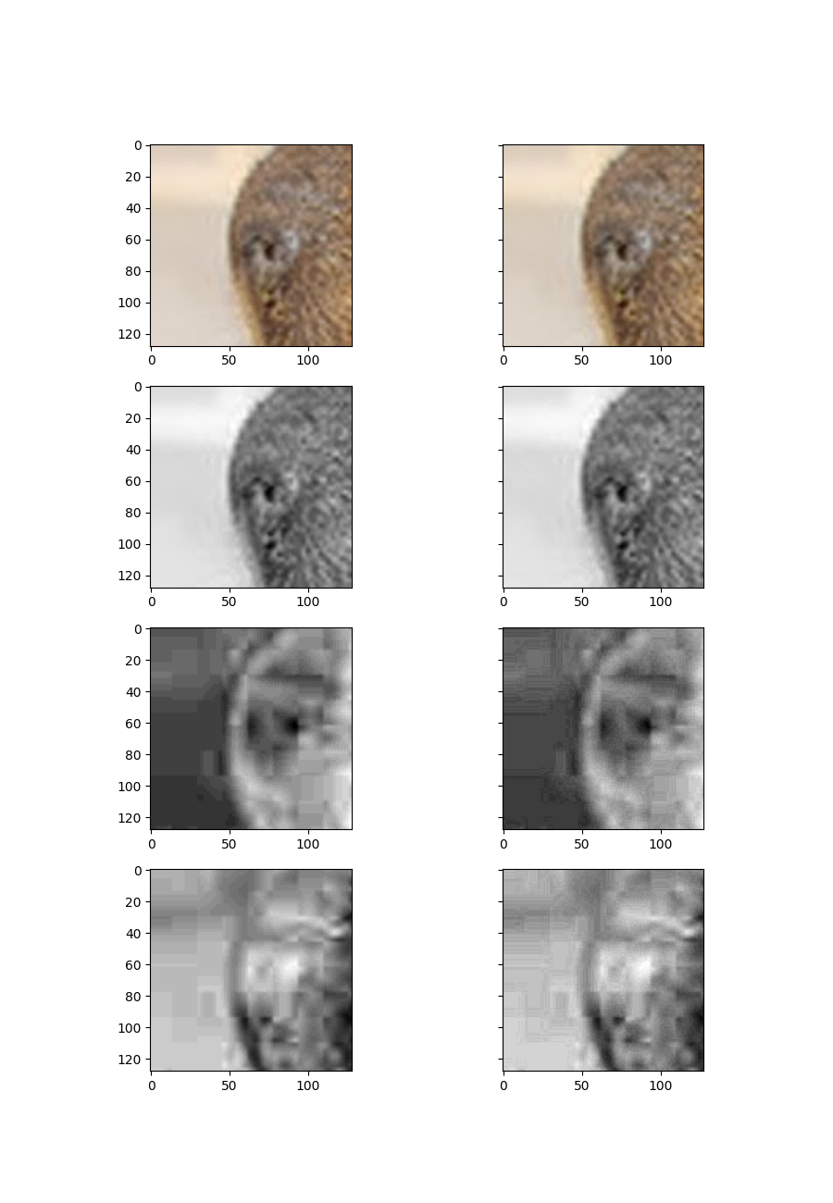

## imgs/capybara.png, section [130, 258, 130, 258], ratio 4:2:2

Y compression: 541.162109375 % , Cr compression 115.869140625% , Cb compression 138.720703125%

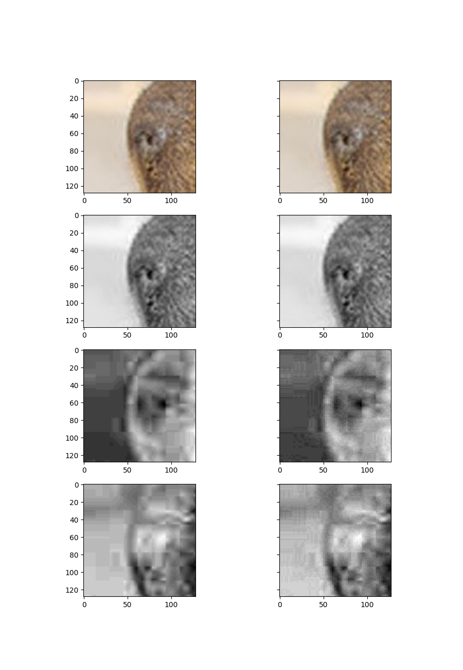

## imgs/capybara.png, section [130, 258, 130, 258], ratio 4:2:0

Y compression: 541.162109375 % , Cr compression 75.048828125% , Cb compression 93.408203125%

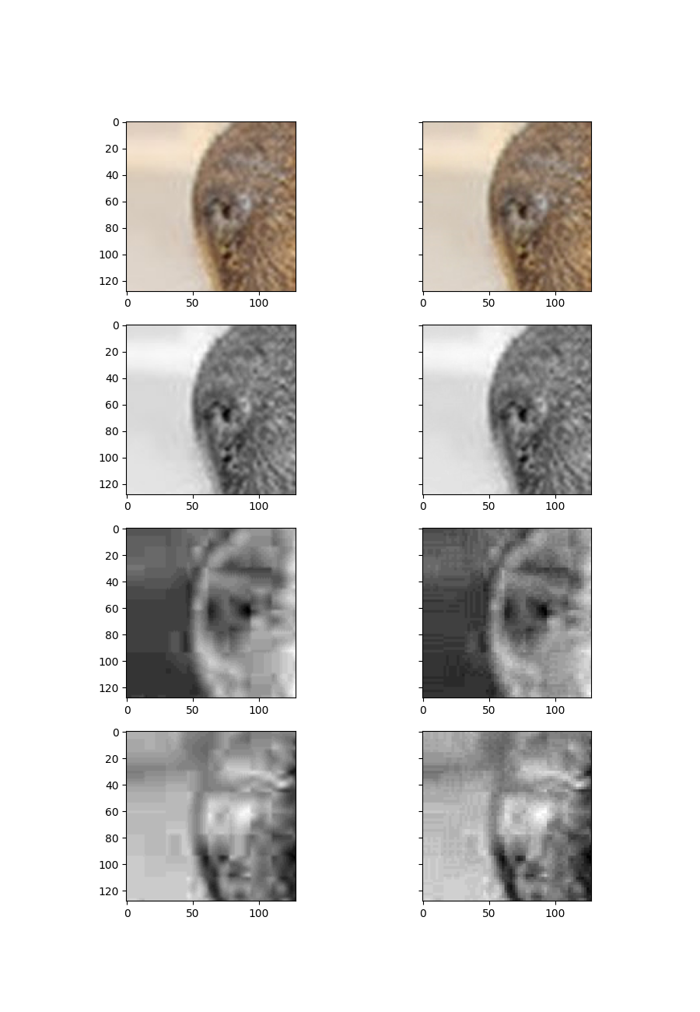

# Wnioski:

Najbardziej zauwazalne różnice w poszczególnych kompresjach, to gdzieniegdzie widoczne szumy oraz dodatkowe efekty na warstwach Chrominancji. Najmocniejsze zakłócenia są widoczne w przypadku zdjęcia cars, fragment 200:328 200:328.

Widoczny jest duży wpływ kodowania bezstratnego, biorąc pod uwagę redukcje kolumn i wierszy. W przypadku ratio 4:2:0, kompresja najczęściej jest najmniejsza ze względu na mniejszą szansę na powtarzanie się danych, przez usunięcie pobliskich, przybliżonych kolorów, przez co pole do redukcji jest mniejsze.